**2.**

**1)**

SELECT color, AVG(StandardCost) AS AVG_StandardCost

FROM [Production].[Product]

WHERE ProductID >=40

GROUP BY Color

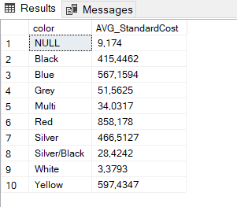

**2)**

SELECT DISTINCT City, COUNT(StateProvinceID) AS_StateProvinceID

FROM [Person].[Address]

GROUP BY City

**3)**

SELECT TOP 5 ProductID, Quantity

FROM [Production].[ProductInventory]

ORDER BY Quantity DESC

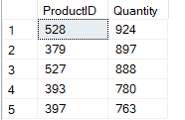

**4)**

SELECT Comments, Rating

FROM [Production].[ProductReview]

WHERE Rating > (SELECT AVG(Rating) FROM Production.ProductReview)



**5)**

SELECT *

FROM Purchasing.ShipMethod

WHERE ShipRate > (SELECT MIN(ListPrice)

FROM Production.Product

WHERE ListPrice > 0 )



**6)** (854 строки)

SELECT p.BusinessEntityID

FROM Person.Person p

LEFT JOIN Sales.PersonCreditCard pc

ON p.BusinessEntityID = pc.BusinessEntityID

WHERE pc.BusinessEntityID IS NULL